**Laurent’s Theorem and Cauchy’s Residue Theorem**

Table of Contents

Laurent’s Theorem 2

Residue in Complex Number 4

Finding Residues 4

Residue Theorem 5

## Laurent’s Theorem

If we are required to **expand $f\left(z\right)$** about a point where $f\left(z\right)$ is **not analytic**, we user **Laurent’s Theorem**.

Say we have **two circles**, $C_{1}$ and $C_{2}$, both with their centre at $a$, one with radius $R_{1}$ and the other with radius $R_{2}$.

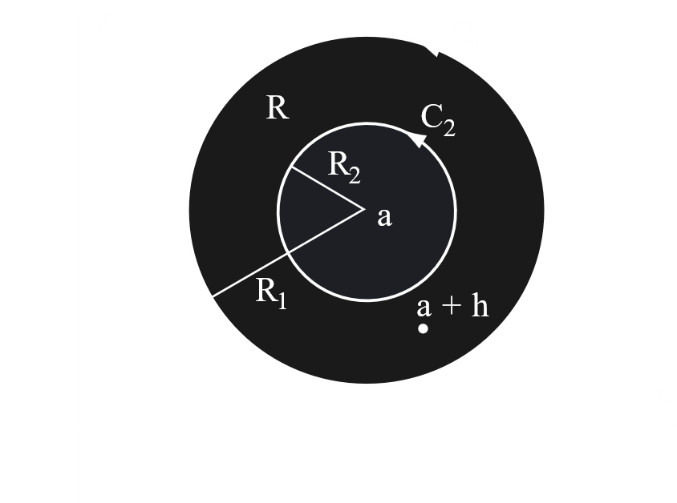

The region **bounded** by the two circles is called an **annular region**. Suppose $f\left(z\right)$ is analytic in this region, but not inside $C_{2}$.

For a scenario like this,

$$f\left(z\right)=a_{0}+a_{1}\left(z-a\right)+a_{2}{\left(z-a\right)}^{2}+…+\frac{b_{1}}{z-a}+\frac{b_{2}}{{\left(z-a\right)}^{2}}+…$$

where

$a_{n}=\frac{1}{2πi}\oint_{C_{1}}^{ }{\frac{f\left(z\right)}{{\left(z-a\right)}^{n+1}}dz}$ $n=0, 1, 2,…$

$b_{n}=\frac{1}{2πi}\oint_{C_{2}}^{ }{{\left(z-a\right)}^{n-1}f\left(z\right)dz}$ $n=1, 2,…$

Here, the part $a_{0}+a_{1}\left(z-a\right)+a_{2}{\left(z-a\right)}^{2}+…$ is called the **analytic** part while the part $\frac{b_{1}}{z-a}+\frac{b_{2}}{{\left(z-a\right)}^{2}}+…$ is called the **principle** part. If the principle part is **zero**, Laurent’s Series reduces to **Taylor’s Series**.

## Residue in Complex Number

If we wish to **integrate** a Laurent’s series term by term, a lot of the integrals will become **zero**. The terms that do not become zero are called **residues**.

The **first coefficient** of the **principle part**, i.e. $b_{1}$, is the residue of $f\left(z\right)$ at $z=a$.

### Finding Residues

1. The residue at a **simple pole** is given by
$$Res f\left(z\right)=\lim_{z→a}\left(z-a\right)f\left(z\right)$$

2. The residue at a **pole or order $n$**  is given by

$$Res f\left(z\right)=\frac{1}{\left(n-1\right)!}{\left[\frac{d^{n-1}}{dz^{n-1}}\left\{{\left(z-a\right)}^{n}f\left(z\right)\right\}\right]}_{z=a}$$

Example

Determine the poles of $\frac{4-3z}{z\left(z-1\right)\left(z-2\right)}$ over $C:\left|z\right|=\frac{3}{2}$ and the residue at each pole.

The poles are $z=0$, $z=1$ and $z=2$.

$$Res f\left(z\right)=\lim_{z→0}\left(z-0\right)f\left(z\right)$$

$$=\lim_{z→0}{\frac{4-3z}{\left(z-1\right)\left(z-2\right)}}$$

$$=2$$

$$Res f\left(z\right)=\lim_{z→1}\left(z-1\right)f\left(z\right)$$

$$=-1$$

Since $z=2$ is outside the region (the circle of radius $\frac{3}{2}$), we can exclude it.

### Residue Theorem

If a function $f\left(z\right)$ is **analytic** in a **closed curve $C$** except at finite poles within $C$, then

$$\int_{C}{f\left(z\right)dz}=2πi\left(sum of residues of all poles within C\right)$$

Example

$\int_{C}{\frac{\left(4-3z\right)}{z\left(z-1\right)\left(z-2\right)}}dz$ over $C:\left|z\right|=\frac{3}{2}$

$$=2πi\left(2-1\right)$$

$$=2πi$$